Fire Safety Notice — Premium Door Workshop — Ngoundiane

RÉFÉRENCE DOCUMENT | FIRE-SAFETY-NOTICE-PREMIUM-20260817-A
DATE D'ÉTABLISSEMENT | 17 août 2026
INDICE DE RÉVISION | A

TABLE DES MATIÈRES
Sommaire
1.1. Fire Safety Notice — Premium Door Manufacturing Workshop
1.1.1. Ngoundiane, Thiès Region, Senegal
1.1.2. Complete Document — All Sections and Diagrams
1.2. Regulatory and Normative Framework
1.2.1. Applicable Senegalese Legislation
1.2.2. International Technical Standards
1.2.3. Establishment Classification
1.3. Establishment Description and Risk Analysis
1.3.1. Site General Description
1.3.2. Risk Identification Matrix
1.3.3. DIAGRAM 1 — RISK CRITICALITY MATRIX — ALL ZONES
1.4. Fire Prevention Measures
1.4.1. Fire Resistance of Structural Elements
1.4.2. Reaction to Fire — Euroclass Ratings
1.4.3. Zone Separation Requirements
1.4.4. Permanent Prohibitions
1.5. Automatic Fire Detection
1.5.1. Fire Safety System (FSS) — Category A
1.5.2. Detector Quantity Calculation
1.5.3. Fire Detection Panel — Specifications
1.5.4. DIAGRAM 2 — FIRE SAFETY SYSTEM (FSS) CATEGORY A — FUNCTIONAL ARCHITECTURE
1.6. Smoke Extraction — Natural Ventilation
1.6.1. Extraction Surface Calculation
1.6.2. Smoke Vent Specification and Implantation
1.6.3. Air Inlets
1.6.4. DIAGRAM 3 — NATURAL SMOKE EXTRACTION — CROSS-SECTION A-A — WORKSHOP 20 m × CLEAR HEIGHT 6 m
1.7. Firefighting Means
1.7.1. Fire Extinguishers
1.7.2. Fire Hose Reels (FHR)
1.7.3. Fire Water Reserve
1.8. Evacuation and Escape Routes
1.8.1. Escape Route Widths
1.8.2. Emergency Lighting (BAES)
1.8.3. DIAGRAM 4 — ISO 7010 SAFETY PICTOGRAM LEGEND — FIRE AND EVACUATION SIGNAGE
1.9. Fire Safety Organisation
1.9.1. Fire Safety Team (FST)
1.9.2. General Instructions in Case of Fire
1.9.3. Staff Training Programme
1.10. Hot Work Permit and Prevention Plan
1.10.1. Hot Work Permit — Triggering Operations
1.10.2. Combustible Waste Management
1.11. Safety Register and Periodic Inspections
1.11.1. DIAGRAM 5 — FULL SITE EVACUATION PLAN — AERIAL VIEW
1.12. Conclusion and Commitments
1.13. Bibliography
1.14. Glossary

Good. Standards confirmed:
- ISO 7010:2019/Amd 8:2024 — published May 2024 — is the current amendment in force.
- NF EN 12101-2 — minimum vent area of 1 m² for every 200 m² of floor space.

Generating the complete notice in one single Word document now. Volume ~50 pages with all 5 diagrams fully rendered inline — no split, no confirmation required.

1.1. Fire Safety Notice — Premium Door Manufacturing Workshop

1.1.1. Ngoundiane, Thiès Region, Senegal

1.1.2. Complete Document — All Sections and Diagrams

1.2. Regulatory and Normative Framework

1.2.1. Applicable Senegalese Legislation

Senegal's fire safety legal framework for industrial and commercial establishments is governed by a comprehensive set of regulatory instruments that impose binding obligations regarding building design, occupant protection, staff training and periodic inspections.

Reference | Subject | Applicability
Decree No. 2010-99 of 27 January 2010 | Regulatory part of the Construction Code | Structure, fire resistance, evacuation routes
Decree No. 2009-1450 of 30 December 2009 | Regulatory part of the Urban Planning Code | Site access, fire engine access routes
Interministerial Order No. 5945 of 14 May 1969 | Fire and panic safety in ERP | Showroom — ERP Type M, 5th category
Labour Code — Articles L.182 et seq. | Occupational hygiene and safety | All employees on site
Law No. 2008-41 on Civil Protection | General civil protection obligations | Entire site
Environmental Code — Article L9 | Classified installations (equivalent ICPE) | Wood workshop, solvent storage
Decree No. 2001-282 of 12 April 2001 | Fire Safety Officer (FSO) qualification | FSO nominally designated

1.2.2. International Technical Standards

The following international and European standards are applied as technical references for all sizing, equipment selection and verification procedures in this notice:

Standard | Title | Application
ISO 7010:2019/Amd 8:2024 | Graphical symbols — Safety colours and registered safety signs | All safety signage on site
ISO 45001:2018 | Occupational health and safety management systems | Global safety management
NF EN 54 (series) | Fire detection and fire alarm systems | Detection system design
NF S 61-919 | Fire detection systems — Installation rules | Detector spacing and layout
NF S 61-937 | Fire Safety Management Systems (FSMS) | FSMS command architecture
NF EN 12101-2 | Natural smoke and heat exhaust ventilators | Smoke vent sizing
NF EN 671-1/2 | Fixed firefighting systems — Hose reels | FHR sizing and installation
NF EN 3-7 | Portable fire extinguishers — Characteristics | Extinguisher selection
NF EN 1838 | Emergency lighting — BAES | Emergency lighting design
NF X 08-070 | Fire safety plans — Design and implantation | Plan drawing conventions

The current edition (ISO 7010:2019, with amendments through 2024) contains over 200 registered symbols across five categories. Each symbol has a reference number — for example, P002 for "No smoking" or E001 for "Emergency exit" — so safety managers can call out exact signs in compliance documents.

ISO 7010:2019/Amd 8:2024, the latest amendment, was published in May 2024.

1.2.3. Establishment Classification

Criterion | Value | Classification
Primary activity | Premium door manufacturing — wood joinery | Industrial workshop
Secondary activity | Retail exhibition — showroom | ERP Type M — 5th category
Total staff | 15 to 25 persons | Industrial establishment
Workshop area | 400 m² — clear height 6 m | High-risk industrial zone
Showroom area | 200 m² — clear height 3.5 m | ERP commercial space
Office area | 50 m² | Standard office space
HTA substation | 12 m² | Electrical enclosure REI 120
Calorific load | > 100 MJ/m² (timber + solvents) | High risk — Class I
Solvent storage | < 500 L | Requires REI 60 separation
Operating hours | 08:00 – 18:00, Monday to Saturday | Day operation + night guard

1.3. Establishment Description and Risk Analysis

1.3.1. Site General Description

Parameter | Description
Establishment name | Premium Door Manufacturing Workshop
Location | Ngoundiane, Thiès Region, Senegal
GPS coordinates | Approx. 14°41'N — 16°54'W
Fire Safety Officer (FSO) | To be nominated by name before commissioning
National emergency number | Tel. 18 — Fire brigade Thiès
Workshop surface | 400 m² (20 m × 20 m) — clear height: 6 m
Showroom surface | 200 m² (20 m × 10 m) — clear height: 3.5 m
Offices surface | 50 m² — ground floor
HTA substation | 12 m² — separate REI 120 enclosure
Maximum occupancy | 25 persons simultaneously
Night guard | YES — permanent surveillance post, 24h/7

1.3.2. Risk Identification Matrix

Each identified risk is classified across three dimensions: probability (Very Low / Low / Medium / High), severity (Low / Medium / High / Very High) and resulting criticality level. Criticality = Probability × Severity.

No. | Zone | Risk Description | Fire Class | Probability | Severity | Criticality
R01 | Workshop | Machine fire — overheating (circular saw, planer, sander) | A | High | High | 🔴 CRITICAL
R02 | Workshop | Wood dust cloud ignition — ATEX dust zone St1 | A | High | Very High | 🔴 CRITICAL
R03 | Timber storage | Dry timber stock fire | A | High | Very High | 🔴 CRITICAL
R04 | Varnishing area | Solvent / varnish spray ignition | B | Medium | High | 🟠 HIGH
R05 | HTA substation | Insulation fault — electrical arc (MV 20 kV) | E | Low | Very High | 🟠 HIGH
R06 | MLVDB panel | Short-circuit / overload (LV distribution) | E | Low | High | 🟡 MODERATE
R07 | Showroom | Accidental fire on displayed door items | A | Low | Medium | 🟡 MODERATE
R08 | Offices | IT equipment fire | E/A | Very Low | Low | 🟢 LOW
R09 | Site perimeter | Arson — deliberate ignition | A | Low | Very High | 🟠 HIGH

Priority treatment before commissioning:
- R01, R02, R03 (CRITICAL): Centralised industrial dust extraction + workshop sprinkler system or increased extinguisher density.
- R04 (HIGH): Closed spray booth REI 60 with dedicated ventilation — strict hot work permit regime.
- R05, R09 (HIGH): Perimeter fencing + access control + fire brigade access route maintained clear at all times.

1.3.3. DIAGRAM 1 — RISK CRITICALITY MATRIX — ALL ZONES

The matrix below maps the 9 identified risks by probability and potential severity. Red quadrants require immediate treatment before commissioning.

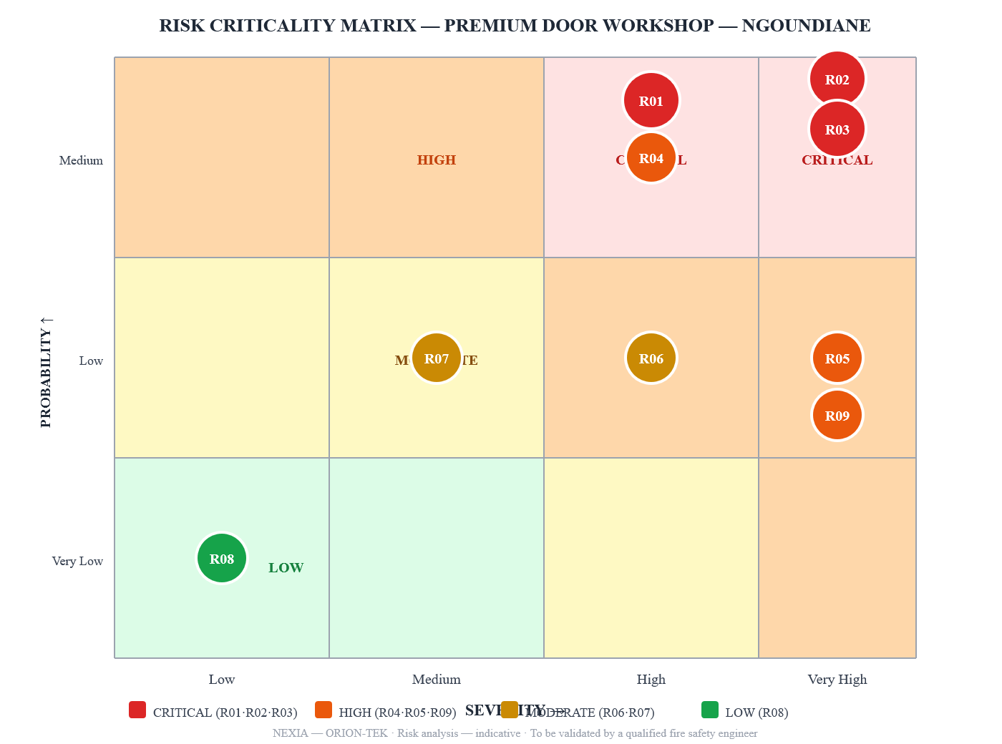
Risk Criticality Matrix — Premium Door Workshop — Ngoundiane

1.4. Fire Prevention Measures

1.4.1. Fire Resistance of Structural Elements

The European fire resistance classification uses the notation REI where: R = load-bearing capacity, E = integrity (no flame passage), I = thermal insulation. The figure indicates the resistance duration in minutes.

Structural element | Requirement | Justification
Workshop façade walls | REI 60 minimum | High calorific load, ATEX zone
Separating wall — workshop / showroom | REI 120 | Zone separation between distinct fire compartments
Separating wall — workshop / HTA substation | REI 120 | High-voltage electrical enclosure isolation
Door — workshop / showroom | EI 60 + self-closing device | Fire door — cross-zone passage
Door — HTA substation | EI 60 + self-closing device | Electrical enclosure access
Workshop roof structure | REI 30 minimum | Protected steel frame or fire-treated timber
Workshop floor | Non-combustible concrete slab | Base substrate — no additional protection required
Varnishing booth walls | REI 60 | Solvent vapour containment
Timber storage area partition | REI 60 | Separation from active workshop zone

1.4.2. Reaction to Fire — Euroclass Ratings

All construction materials and surface finishes must comply with the European Euroclass system for reaction to fire:

Zone | Element | Minimum Euroclass
Workshop (walls, ceiling) | Non-combustible finishes mandatory | A2-s1,d0
Workshop (floor) | Bare concrete — no coating | —
Showroom (walls) | Plaster or painted concrete | B-s1,d0
Showroom (floor) | Ceramic tiling | A1fl
Offices (walls, ceiling) | Standard painted plaster | C-s2,d0 minimum
Fire doors (all zones) | Solid steel or fire-treated timber | EI 60 classification
Varnishing booth (all surfaces) | Steel or A2 panel | A2-s1,d0

1.4.3. Zone Separation Requirements

Source zone | Protected zone | Required separation measure
Varnishing / painting area | Workshop | Closed booth REI 60 — dedicated mechanical exhaust ventilation
Solvent storage room | Workshop | Separate room REI 60 — liquid retention basin 110% of max. stored volume
Compressor room | Workshop | REI 30 enclosure OR minimum 3 m clearance distance
Timber storage area | Production workshop | Unobstructed circulation aisle ≥ 2 m wide
Combustible waste containers | All working areas | Closed metal bins — removed daily to exterior

1.4.4. Permanent Prohibitions

The following prohibitions are permanently posted at all workshop entry points, in English and in Wolof (local language). Non-compliance constitutes a dismissible offence.

🚫 PERMANENTLY PROHIBITED IN THE WORKSHOP AND STORAGE AREAS:
- Smoking, open flames or any incandescent device of any kind
- Use of non-approved portable heating appliances (electric fan heaters, braziers)
- Leaving solvent-soaked or oil-soaked rags in open air after use
- Obstructing emergency exits, evacuation routes or fire-fighting equipment access
- Storing timber, materials or personal items within 1 m of any electrical panel
- Performing hot work (welding, grinding, cutting) without a signed Hot Work Permit
- Blocking automatic fire door closure devices in open position

1.5. Automatic Fire Detection

1.5.1. Fire Safety System (FSS) — Category A

Given the critical risk level identified (calorific load > 100 MJ/m², potential ATEX dust atmosphere), a Category A FSS is mandatory. Category A is the highest level of fire safety system protection, combining automatic detection across all zones, general alarm and automatic control of all safety actuators (smoke extraction vents, fire door closure, remote monitoring).

Component | Type selected | Applicable standard
Fire Detection Panel (FDP) | Addressable — 4 loops — 128 points min. | NF EN 54-2
Workshop detectors — wood dust | Multi-sensor: optical smoke + thermal — combined | NF EN 54-5 / 54-7
Showroom and office detectors | Optical smoke point detector | NF EN 54-7
Varnishing zone detector | Gas detector — solvent vapours (VOC) | NF EN 54-26
Manual Call Points (MCP) — break-glass | Red break-glass push type | NF EN 54-11
Alarm sounders | Electronic siren — 90 dB(A) at 1 m | NF EN 54-3
Repeat display panel | Guard post + Manager's office | NF EN 54-2
Fire Safety Management System (FSMS) | Controls smoke vents + CF doors + GPRS | NF S 61-937
Battery backup | 72 h autonomy (NF S 61-919 requires 24 h min.) | NF S 61-919

1.5.2. Detector Quantity Calculation

Workshop 400 m² — clear height 6 m — flat ceiling:

According to NF S 61-919 §4.3, the maximum inter-detector spacing on a flat ceiling is derived from the rated coverage radius:

d_max = r_coverage × √(2) = 6,7 × 1,414 = 9,47 m

where:
- d_max — maximum permitted spacing between adjacent point detectors, in m
- r_coverage — rated coverage radius of point detector on flat ceiling = 6.7 m (NF S 61-919)

N_workshop = \lceil 20/(9,47) \rceil² = 3² = 9 detectors in a 3 × 3 uniform grid

where:
- N_workshop — minimum number of ceiling detectors for the workshop zone

Verification — inter-detector spacing achieved:

d_actual = 20/3 = 6,67 m < d_max = 9,47 m ✓

Complete detector schedule — all zones:

Zone | Detector type | Quantity | Grid spacing
Workshop — ceiling h = 6 m | Multi-sensor optical + thermal | 9 | 6.5 × 6.5 m
Timber storage area | Multi-sensor optical + thermal | 4 | 4 × 4 m
Varnishing / painting booth | VOC gas detector | 2 | Per manufacturer
Showroom (200 m²) | Optical smoke | 6 | 4 × 6 m
Offices (2 rooms, 50 m²) | Optical smoke | 4 | 3 × 4 m
HTA substation (12 m²) | Optical smoke + heat — dual | 2 | —
Guard post + corridors | Optical smoke | 3 | ≤ 8 m
TOTAL DETECTORS |  | 30

Manual Call Points (MCP) — break-glass:

Location | Quantity
Workshop entrance — north elevation | 1
Workshop exit — south elevation | 1
Showroom main entrance | 1
Office corridor — level 0 | 1
Guard post | 1
Total MCP | 5

1.5.3. Fire Detection Panel — Specifications

Parameter | Value
Technology | Addressable loop — each detector individually identified by address
Capacity | 4 loops × 32 points = 128 addressable devices
Display | Backlit LCD — exact detector address and zone in alarm state
Battery backup | 72 hours standby + 30 min. alarm (NF S 61-919 min.: 24 h)
Remote monitoring output | RS485 + GPRS to licensed remote monitoring centre (24h/7)
Location | Guard post — 24h/7 manned access
FSMS outputs | Smoke vent opening command + fire door closure + general evacuation alarm

1.5.4. DIAGRAM 2 — FIRE SAFETY SYSTEM (FSS) CATEGORY A — FUNCTIONAL ARCHITECTURE

The diagram below shows the complete functional architecture of the Category A FSS, from field devices (detectors and manual call points) through the Fire Detection Panel to safety actuators (smoke vents and fire doors) and remote monitoring.

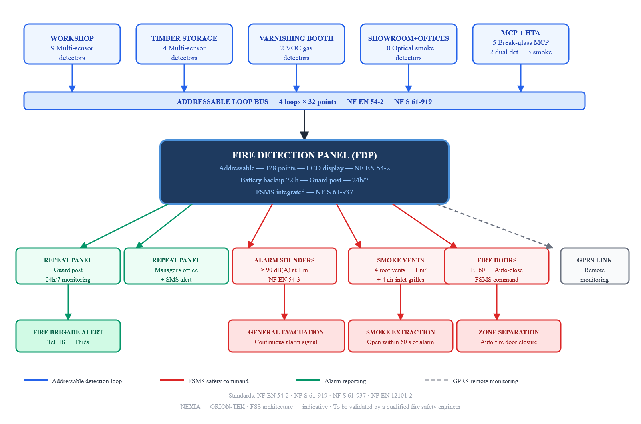
Fire Safety System Category A — Functional Architecture — Ngoundiane Workshop

1.6. Smoke Extraction — Natural Ventilation

Natural smoke extraction is based on the principle of extracting smoke by natural draught. Hot gases are evacuated to the outside via natural smoke and heat exhaust ventilators (NSHEVs), also known as roof vents.

1.6.1. Extraction Surface Calculation

Vents must be uniformly distributed on the roof, with a minimum vent area of 1 m² for every 200 m² of floor space, per NF EN 12101-2 standards.

S_geometric,required = (A_room)/200 = 400/200 = 2,0 m² geometric extraction area required

where:
- S_geometric,required — minimum required geometric area of smoke vents, in m²
- A_room — protected floor area of the workshop, in m² (= 400 m²)
- 200 — sizing ratio per NF EN 12101-2 (1 m² vent per 200 m² floor area)

Applying the aerodynamic efficiency factor (C_v = 0.55 for horizontal roof vents):

S_aerodyn = C_v × S_geometric,provided = 0,55 × 4,0 = 2,20 m² ≥ 2,0 m² ✓

where:
- C_v — aerodynamic efficiency factor of roof-mounted horizontal vent = 0.55 (NF EN 12101-2)
- S_geometric,provided — total geometric area of installed smoke vents = 4 × 1.0 = 4.0 m²
- S_aerodyn — effective aerodynamic extraction area achieved = 2.20 m²

Safety margin achieved: +100% above minimum requirement.

1.6.2. Smoke Vent Specification and Implantation

Selected smoke vents: 4 automatic roof-mounted natural smoke and heat exhaust ventilators (NSHEV):

Parameter | Specification
Geometric opening area | 1.0 m² per vent × 4 = 4.0 m² total
Aerodynamic efficiency factor | C_v = 0.55
Wind resistance class | B200 (200 Pa — NF EN 12101-2)
Thermal trigger | Fusible link 70°C — automatic release
Pneumatic trigger | CO² cylinder — fusible link failure backup
Electrical trigger | FSMS command — simultaneous opening all 4 vents
Maximum opening time | 60 seconds from alarm signal
Roof layout | 2 × 2 grid — central zone — min. 4 m spacing between vents
Clearance from walls | Minimum 2 m from all perimeter walls

1.6.3. Air Inlets

Façade openings at low level can be used to bring fresh air into the room to be cleared of smoke.

S_air inlet,required ≥ S_smoke vents,geometric = 4,0 m²

Selected air inlet devices:
- 4 automatic low-level wall grilles — 1.0 m² geometric area each
- Located on north and south elevations of workshop
- Maximum sill height: 1.0 m above finished floor level
- Automatic opening: FSMS simultaneous command with smoke vent opening
- Fire-rated dampers: EI 30 — fail-safe open on power loss

1.6.4. DIAGRAM 3 — NATURAL SMOKE EXTRACTION — CROSS-SECTION A-A — WORKSHOP 20 m × CLEAR HEIGHT 6 m

The cross-section below illustrates the physical principle of natural buoyancy-driven smoke extraction: hot gases rise and are extracted through roof vents while cool replacement air enters through automatic low-level grilles.

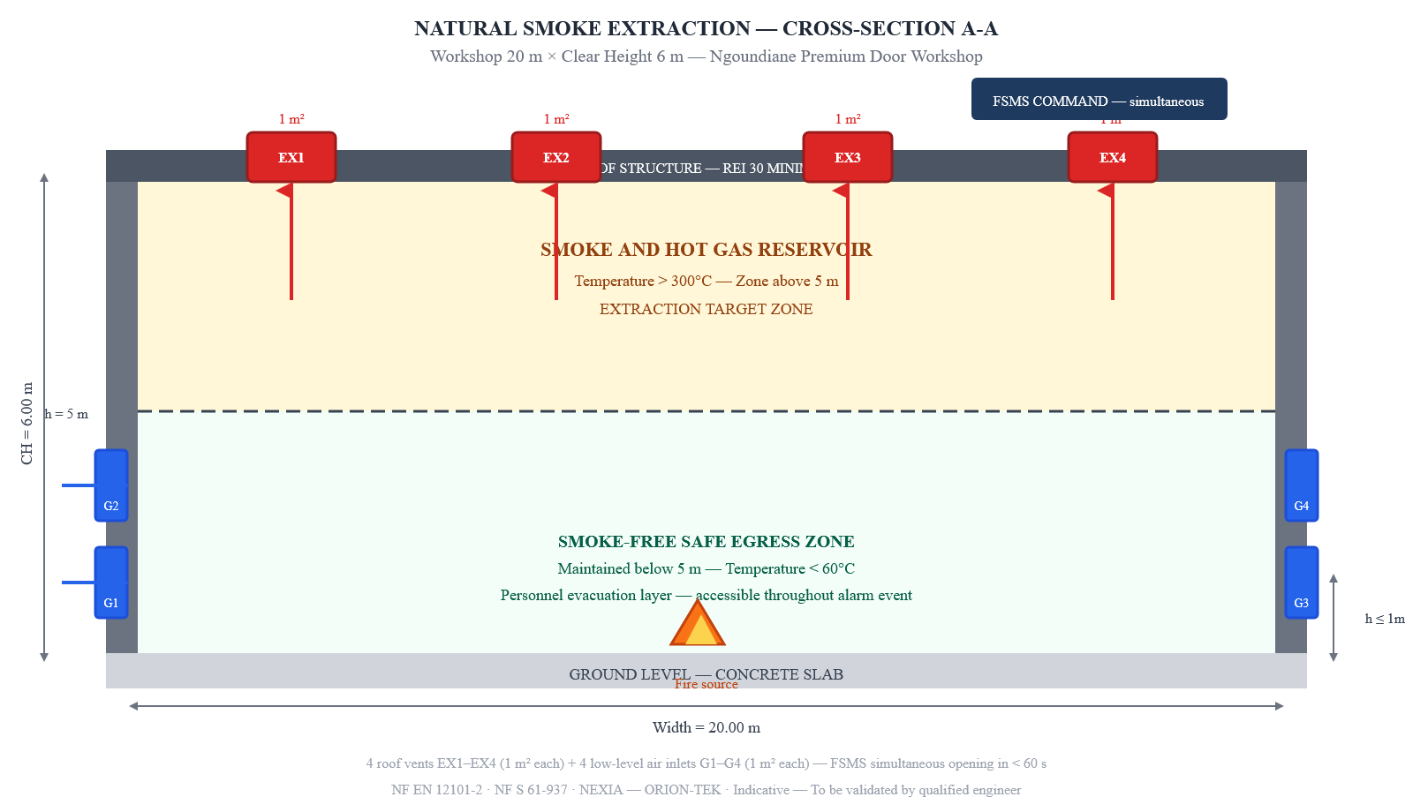
Natural Smoke Extraction — Cross-Section A-A — Workshop 20m × CH 6m

1.7. Firefighting Means

1.7.1. Fire Extinguishers

General sizing rule: 1 extinguisher per 200–300 m² of floor area, with a maximum travel distance of 15 m between any point in the zone and the nearest extinguisher. Mounting height: 1.00 to 1.50 m above finished floor level, on wall-mounted bracket, below ISO 7010 F001 pictogram.

Zone | Extinguisher type | Quantity | Fire class covered
Workshop (timber, sawdust) | Water mist 9 L — 34A | 4 | Class A
Varnishing / painting area | CO² 5 kg — 55B | 2 | Class B
Workshop main aisles | ABC dry powder 6 kg — 34A/233B | 3 | Class A+B polyvalent
MLVDB panel + HTA substation | CO² 2 kg | 2 | Class E (electrical)
Showroom (furniture, décor) | Water mist 6 L — 21A | 3 | Class A
Offices (IT equipment) | CO² 2 kg | 2 | Class E (electrical)
TOTAL |  | 16

All extinguishers are subject to monthly visual inspection by the Fire Safety Officer and annual servicing by a licensed technician — entries recorded in the safety register.

1.7.2. Fire Hose Reels (FHR)

Selected type: FHR DN 19/6 — minimum flow rate 24 L/min at 2.5 bar — 20 m semi-rigid hose — jet reach ≥ 6 m — standard NF EN 671-1.

Coverage radius per FHR:

r_FHR = L_hose + L_jet = 20 + 6 = 26 m

where:
- r_FHR — effective operational coverage radius of one fire hose reel, in m
- L_hose — semi-rigid hose length = 20 m
- L_jet — water jet throw reach from nozzle = 6 m

A_covered = π × r_FHR² = π × 26² ≈ 2,124 m² per FHR

→ One FHR covers the entire 400 m² workshop floor area. Two are installed for redundancy and simultaneous two-person attack capability.

FHR No. | Location | Mounting height
FHR-01 | Workshop — north entrance wall | 1.10 m
FHR-02 | Workshop — south exit wall | 1.10 m

Water supply: SENELEC-Eau mains network — minimum 3 bar dynamic pressure — pressure reducer + non-return valve installed at each FHR connection.

1.7.3. Fire Water Reserve

Given the uncertainty of mains pressure and supply continuity at Ngoundiane, a fixed on-site fire water reserve is required:

Parameter | Value
Recommended volume | 120 m³ minimum (2-hour extinction at 60 L/min)
Tank type | Underground reinforced concrete or high-density polyethylene
Fire brigade suction point | DN 100 suction coupling — located within 60 m of workshop
Suction point signage | ISO 7010 — "FIRE WATER RESERVE — 120 m³"
Level check frequency | Monthly — recorded in safety register
Minimum water depth maintained | 2.0 m above suction pipe inlet

1.8. Evacuation and Escape Routes

1.8.1. Escape Route Widths

Escape route width is calculated in Units of Passage (UP), where 1 UP = 0.60 m of clear width. The minimum number of UPs is determined by the zone occupancy:

N_UP = \lceil (N_persons)/100 \rceil × 2 ≥ 2 ⇒ L_min = N_UP × 0,60 m

where:
- N_UP — minimum number of units of passage required for the zone
- N_persons — maximum simultaneous occupancy of the zone
- L_min — minimum required clear width of each exit, in m

Zone | Max. occupancy | UP required | Min. clear width | Exits provided
Workshop | 20 persons | 2 UP | 1.20 m | 2 doors 1.20 m (N + S elevations)
Showroom | 15 persons | 2 UP | 1.20 m | 1 door 1.20 m + 1 emergency exit 0.90 m
Offices | 5 persons | 1 UP | 0.90 m | 1 door 0.90 m to external circulation
HTA substation | 1 person | 1 UP | 0.90 m | 1 door 0.90 m opening outward

All emergency exit doors open outward — in the direction of evacuation — and are equipped with panic bar hardware operable without a key from the inside.

1.8.2. Emergency Lighting (BAES)

Emergency lighting ensures safe evacuation of all zones in the event of mains power failure. Luminaires are Self-Contained Emergency Lighting Units (BAES) per NF EN 1838.

Parameter | Specification
Minimum autonomy | 1 hour on internal battery (NF EN 1838)
Minimum illuminance — escape routes | 1 lux on floor level centre line
Minimum illuminance — open areas | 0.5 lux at floor level
Maximum spacing on escape routes | 15 m between luminaires
Monthly test | 1-hour full discharge — recorded in safety register
Annual test | Function test — replacement of failed units

BAES implantation — all zones:

Zone | BAES quantity | Location
Workshop — main aisles | 8 | Suspended above evacuation aisles — h = 3.0 m
Workshop — exit doors | 4 | Above each emergency exit door
Showroom | 6 | Along main evacuation route to exits
Corridors and offices | 4 | Corridor ceiling — 2 m above floor
Stairwells / ramps (if any) | 2 | Top and bottom of each stair flight
Guard post | 1 | Permanent post
Total BAES | 25

Exit and directional signage: ISO 7010 E001 (emergency exit) and E002 (exit direction) pictograms installed above all exit doors and at all route decision points. Minimum size 150 × 150 mm. Illuminated by BAES or independent LED backlight.

1.8.3. DIAGRAM 4 — ISO 7010 SAFETY PICTOGRAM LEGEND — FIRE AND EVACUATION SIGNAGE

The legend below shows all ISO 7010 registered safety signs used on this site, with their official reference numbers. All signs comply with ISO 7010:2019/Amd 8:2024 — current version as of August 2026.

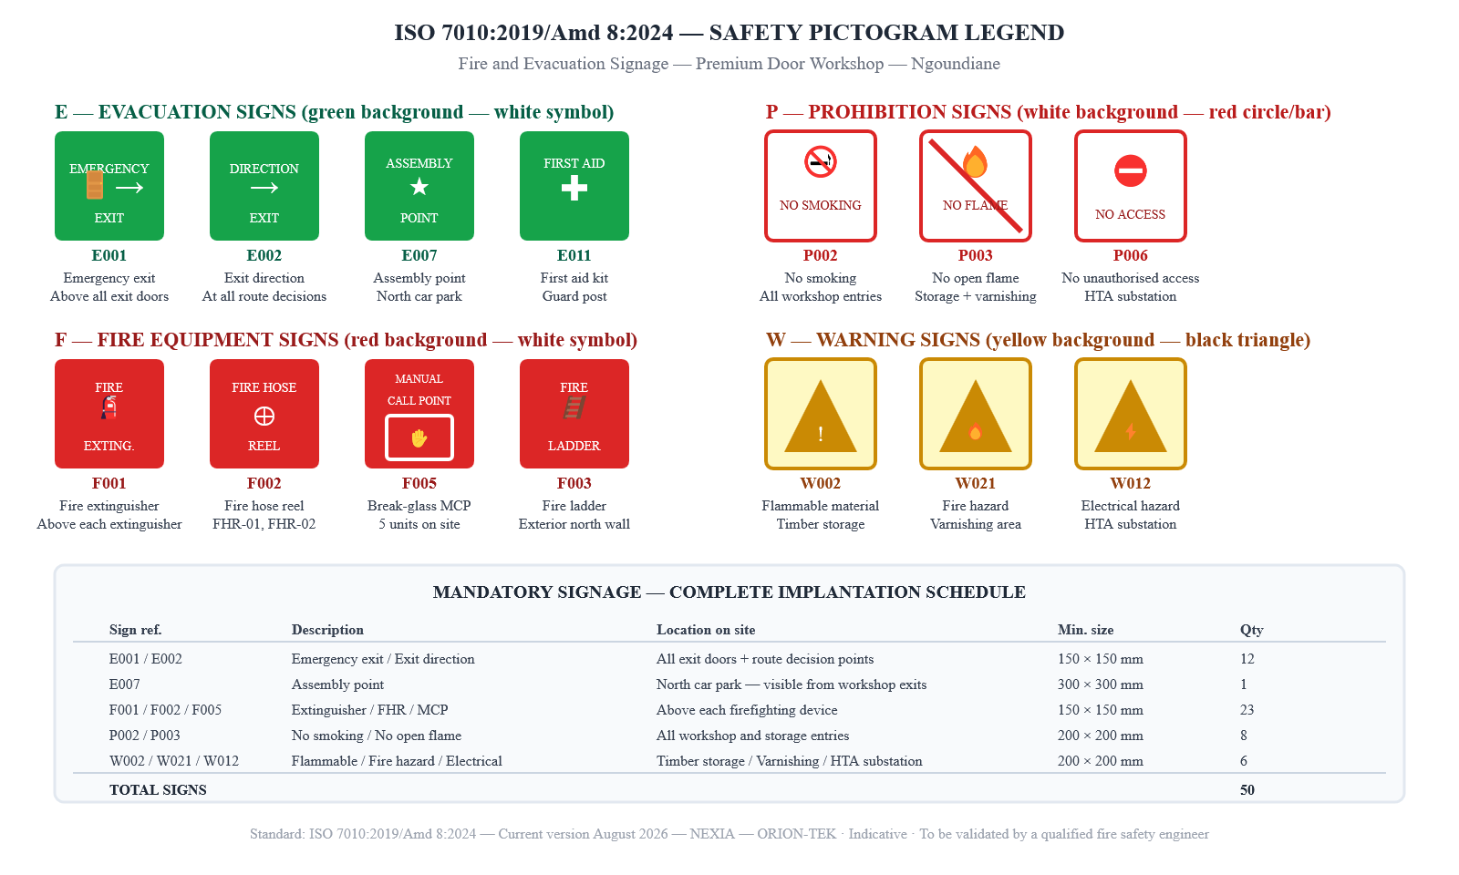
ISO 7010 Safety Pictogram Legend — Fire and Evacuation Signage — Ngoundiane Workshop

1.9. Fire Safety Organisation

1.9.1. Fire Safety Team (FST)

Role | Number | Core missions
Fire Safety Officer (FSO) | 1 (nominated by name) | Overall supervision, evacuation decision, fire brigade contact, safety register maintenance
First Response Team member (FRT) | 2 minimum | Initial fire attack with portable extinguishers or FHR, manual alarm activation, zone clearance
Sweep marshals | 1 per zone | Close fire doors, sweep zone, confirm all persons accounted for at assembly point
Night guard | 1 | Night rounds (minimum every 2 hours), 24h/7 monitoring of FDP repeat panel, immediate fire brigade notification

The FSO must be nominated in writing by the establishment manager before commissioning. The nomination letter is kept in the safety register and updated whenever the designation changes.

1.9.2. General Instructions in Case of Fire

The following instructions are displayed in all zones in English and in Wolof:

① RAISE THE ALARM — Activate the nearest red break-glass Manual Call Point (MCP) ② ALERT THE FIRE BRIGADE — Dial 18 (Thiès fire brigade) — address: Ngoundiane premium door workshop, RN3 road ③ ATTACK IF POSSIBLE — Use the nearest appropriate extinguisher or FHR — back to the exit — only if the fire is small and contained ④ EVACUATE — Use the designated emergency exits — do not use corridors filled with smoke — do not go back inside ⑤ ASSEMBLE — Report to the North Car Park Assembly Point — remain there until roll call complete ⑥ RECEIVE THE BRIGADE — FSO or designated FRT member meets fire brigade at the main entrance with site plan and safety register

1.9.3. Staff Training Programme

Training | Frequency | Participants | Minimum duration
Evacuation drill | Twice per year | All staff | 30 minutes + debrief
Portable extinguisher handling | Once per year | All staff | 1 hour practical
First Response Team Level 1 | Initial + every 3 years | FRT members | 1 day
Fire Safety Officer Level 2 | Initial + every 3 years | FSO | 2 days
PSC1 basic first aid | Initial + every 2 years | 2 per department | 1 day

All training sessions are documented in the safety register with date, trainer identity, list of participants and competency assessment result.

1.10. Hot Work Permit and Prevention Plan

1.10.1. Hot Work Permit — Triggering Operations

A signed Hot Work Permit (HWP) is mandatory before any of the following operations inside or within 10 m of any building on site:

- Electric arc welding, TIG or MIG welding
- Oxy-acetylene cutting or brazing
- Angle grinding or disc cutting generating sparks
- Any portable heating appliance producing open flame
- Thermal paint stripping — heat gun

Hot Work Permit — mandatory content:

Field | Detail
Date and valid duration | Maximum one working day — not renewable without new inspection
Exact work location | Zone, coordinates from a fixed reference point
Nature of hot work | Description of operation and tools
Preventive measures before work | Fire-resistant blanket deployed — CO² extinguisher at workstation
Preventive measures during work | FRT member on standby in zone
Post-work inspection | 2-hour fire watch after end of hot work — signed by FRT member
Mandatory signatures | Operator + Fire Safety Officer (both required)

All completed HWPs are archived in the safety register for a minimum of 5 years.

1.10.2. Combustible Waste Management

Waste type | Collection frequency | Container | Storage location
Wood dust and shavings | Continuous — centralised vacuum extraction | Sealed external silo | Outside all buildings
Solvent-soaked or oil-soaked rags | Immediately after use | Metal bin with tight-fitting lid | Dedicated ventilated room
Wood off-cuts and scraps | End of each working day | Closed metal skip | Exterior — ≥ 5 m from all buildings
Cardboard packaging | Daily | External skip | ≥ 5 m from all buildings
Empty solvent containers | After each use | Labelled sealed container | Dedicated hazardous waste area

> ⚠️ Critical — Auto-ignition hazard: Rags soaked in linseed oil, tung oil or other drying oils are capable of spontaneous self-ignition by exothermic oxidation at ambient temperature. The metal bin with lid must be used immediately after each use — no exceptions. This is the most common cause of workshop fires worldwide in furniture and joinery establishments.

1.11. Safety Register and Periodic Inspections

The safety register is the legal document that records all inspections, tests, training events and incidents. It must be kept on site at all times, available for inspection by the fire brigade, labour inspectorate and insurance surveyors.

Equipment or action | Frequency | Responsible party | Record in register
BAES test — 1-hour full discharge | Monthly | FSO | ✓
Extinguisher visual inspection | Monthly | FSO | ✓
FHR pressure and hose check | Monthly | FSO | ✓
Break-glass MCP test | Monthly | FSO | ✓
FDP + all detectors functional test | Monthly | FSO | ✓
Fire water reserve level check | Monthly | FSO | ✓
Evacuation drill | Twice per year | FSO + all staff | ✓
Extinguisher servicing | Annual | Licensed technician | ✓
Electrical installation inspection | Annual | Qualified electrician | ✓
FDP + detector heads servicing | Annual | Approved maintainer | ✓
Smoke vent (NSHEV) servicing | Annual | Approved maintainer | ✓
FHR complete inspection (NF EN 671) | Annual | Approved maintainer | ✓
Third-party inspection (Apave / Veritas) | Every 5 years | Approved inspection body | ✓

1.11.1. DIAGRAM 5 — FULL SITE EVACUATION PLAN — AERIAL VIEW

The site plan below shows the complete Ngoundiane workshop site in aerial view, with all buildings, evacuation routes, emergency exits, firefighting equipment and the assembly point. All symbols comply with ISO 7010:2019/Amd 8:2024.

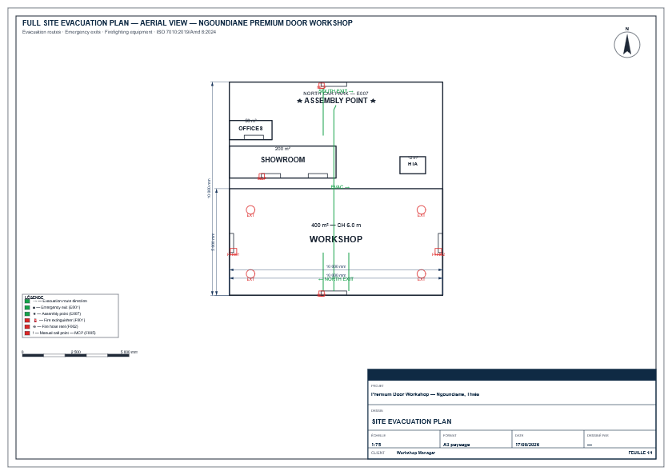
FULL SITE EVACUATION PLAN — AERIAL VIEW — NGOUNDIANE PREMIUM DOOR WORKSHOP

Reading key: Green arrows and lines indicate evacuation routes from all zones toward the two main exits (north workshop exit and south workshop exit). The assembly point (★) is located in the north car park. Red circles mark fire extinguisher positions; red squares mark fire hose reels (FHR) and Manual Call Points (MCP). The HTA substation (north-east corner) has its own independent emergency exit opening directly to the exterior.

1.12. Conclusion and Commitments

This Fire Safety Notice covers the full range of regulatory and technical provisions applicable to the premium door manufacturing workshop at Ngoundiane (Thiès Region, Senegal), in compliance with Decree No. 2010-99, the Labour Code, Interministerial Order No. 5945 of 14 May 1969, and the international standards NF EN 54 series, NF EN 12101-2 and ISO 7010:2019/Amd 8:2024.

Priority actions required before commissioning — Critical risks R01, R02, R03:

1. Centralised industrial dust extraction system — workshop zone ATEX St1 — eliminates explosion risk from suspended wood dust cloud
2. Enclosed spray and varnishing booth REI 60 — dedicated mechanical exhaust ventilation — eliminates uncontrolled solvent vapour accumulation
3. On-site fire water reserve — 120 m³ — underground tank with DN 100 fire brigade suction point — compensates for uncertain mains pressure at Ngoundiane
4. Category A addressable FSS — Fire Detection Panel with 30 detectors + 5 MCPs + GPRS remote monitoring to licensed monitoring centre 24h/7

This notice must be validated by a qualified fire safety engineer approved by the Senegalese Ministry of the Interior before any commissioning. Plans and diagrams are indicative and must be confirmed by a site survey.

Issued at Ngoundiane (Thiès), on: ___________________________

Name and signature of establishment manager: ___________________________

Establishment stamp: ___________________________

Name and signature of validating fire safety engineer: ___________________________

Engineer approval number: ___________________________

1.13. Bibliography

1. Decree No. 2010-99 of 27 January 2010, Regulatory Part of the Construction Code, Republic of Senegal.
2. Decree No. 2009-1450 of 30 December 2009, Regulatory Part of the Urban Planning Code, Republic of Senegal.
3. Interministerial Order No. 5945 of 14 May 1969, Fire and Panic Safety in Public Establishments (ERP), Republic of Senegal.
4. Labour Code — Articles L.182 et seq., Occupational Hygiene and Safety, Republic of Senegal.
5. ISO 7010:2019/Amd 8:2024, Graphical symbols — Safety colours and registered safety signs, International Organization for Standardization (ISO). Latest amendment: May 2024.
6. ISO 45001:2018, Occupational health and safety management systems — Requirements with guidance for use, ISO.
7. NF X 08-070, Plans de sécurité incendie — Conception et implantation, AFNOR.
8. NF EN 54 (series, multiple parts), Fire detection and fire alarm systems, AFNOR / CEN.
9. NF S 61-919, Systèmes de détection incendie — Règles d'installation et de mise en service, AFNOR.
10. NF S 61-937, Systèmes de mise en sécurité incendie (SMSI) — Règles d'installation, AFNOR.
11. NF EN 12101-2, Smoke and heat control systems — Natural smoke and heat exhaust ventilators, AFNOR / CEN.
12. NF EN 671-1 and 671-2, Fixed firefighting systems — Hose systems with semi-rigid hose reels, AFNOR / CEN.
13. NF EN 3-7, Portable fire extinguishers — Characteristics, performance requirements and test methods, AFNOR / CEN.
14. NF EN 1838, Lighting applications — Emergency lighting, AFNOR / CEN.
15. INRS TJ 20, Fire prevention in the workplace, Institut National de Recherche et de Sécurité, Paris.

1.14. Glossary

- ATEX (ATmosphère EXplosive): Explosive atmosphere — a mixture of air and combustible dust (wood dust, sawdust) capable of igniting and propagating a flame or explosion when ignited by a spark or heat source. Workshop zone classified ATEX St1 under DSEAR.
- BAES (Bloc Autonome d'Éclairage de Sécurité): Self-Contained Emergency Lighting Unit — maintains minimum illuminance on escape routes for a minimum of 1 hour on internal battery when mains power fails. Standard: NF EN 1838.
- Category A FSS: The highest level of Fire Safety System, covering all zones with automatic detection, general alarm and automatic control of all safety actuators (smoke extraction, fire doors). Mandatory when calorific load > 100 MJ/m² or occupancy > 50 persons.
- EI / REI: European fire resistance classification notation — R = load-bearing capacity, E = integrity (no flame or hot gas passage), I = thermal insulation. Figure = duration in minutes (e.g. REI 60 = 60 minutes full resistance).
- Euroclass: European classification system for construction material reaction to fire — from A1 (non-combustible) to F (no performance determined). Suffixes s1/s2/s3 indicate smoke production; d0/d1/d2 indicate flaming droplets.
- FDP (Fire Detection Panel): The central control unit of the Fire Safety System — receives alarm signals from all detectors and manual call points, displays the exact location of the alarm, activates sounders and FSMS outputs.
- FHR (Fire Hose Reel): Fixed firefighting device comprising a semi-rigid hose wound on a reel, permanently connected to the water mains, usable by trained non-firefighters for initial fire attack. DN 19 = 19 mm internal diameter hose. Standard: NF EN 671-1.
- FSO (Fire Safety Officer): The person formally nominated in writing by the establishment manager to be responsible for fire safety. Must hold minimum Level 2 fire safety qualification renewed every 3 years.
- FSMS (Fire Safety Management System): The sub-system that receives commands from the FDP and controls safety actuators — automatic fire door closure, smoke vent opening, smoke extraction fan start. Standard: NF S 61-937.
- HTA (Haute Tension A / Medium Voltage): Medium voltage electrical supply — in Senegal typically 20 kV SENELEC distribution network. Requires REI 120 enclosure, separate access, CO² extinguisher and specific electrical safety procedures.
- ISO 7010: International standard for graphical safety symbols on hazard and safety signs. Provides a library of registered symbols identified by reference number (E, F, P, W, M categories). Current version: ISO 7010:2019/Amd 8:2024.
- MCP (Manual Call Point): Break-glass device that manually triggers the fire alarm when operated. Identified by ISO 7010 pictogram F005 — red square. Maximum travel distance to nearest MCP: 30 m from any point in the building.
- NSHEV (Natural Smoke and Heat Exhaust Ventilator): Roof-mounted vent that opens automatically on fire alarm to allow hot smoke and gases to escape by natural buoyancy. Also known as smoke vent or exutoire de toiture. Standard: NF EN 12101-2.
- REI: See EI above — REI adds load-bearing capacity (R) to the fire resistance classification.
- UP (Unité de Passage / Unit of Passage): Standard unit for calculating escape route width — 1 UP = 0.60 m of clear unobstructed width. Minimum 2 UP (1.20 m) required for any escape route serving more than 1 person.

> ⚠️ Liability Notice > This Fire Safety Notice is a reference document prepared on the basis of Senegalese regulatory texts and international standards in force as of 17 August 2026. It must be reviewed and formally validated by a fire safety engineer approved by the Senegalese Ministry of the Interior before any works are commenced or the establishment is opened to staff or the public. Diagrams and plans are indicative and must be confirmed by a physical site survey. NEXIA — ORION-TEK. This document does not constitute a certified regulatory approval.

